## **QA Process**

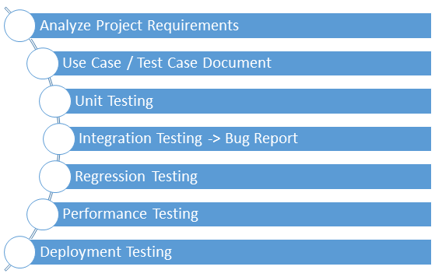

### **Analyze Project Requirements**

### **Use Case**

### **Test Case**

Also give difference between them

### **Unit Testing**

### **Integration Testing**

### **Bug Report**

Also add template

### **Regression Testing**

### **Performance Testing**

Load testing

Stress testing

### **Deployment Testing**

Release notes, version control. Also add links for template